**Installing Openstack:**

* Install virtual box.
* Create three host-only adapters in our virtual box. Configure them as Paravirtualized and allow all the VMs to access them.
* Create three nodes on virtual box: controller, compute and network

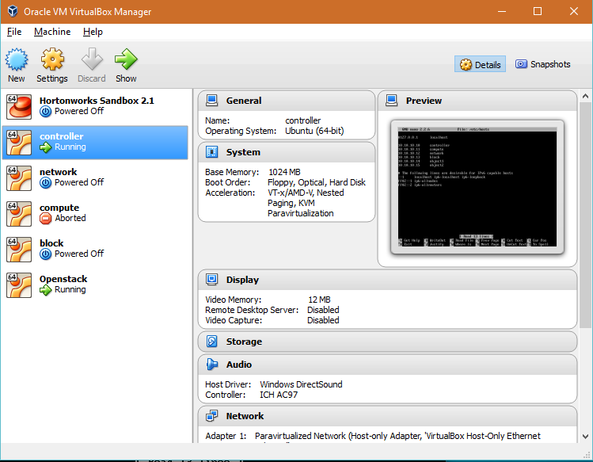

* Configure the nodes with their respective host IPs.

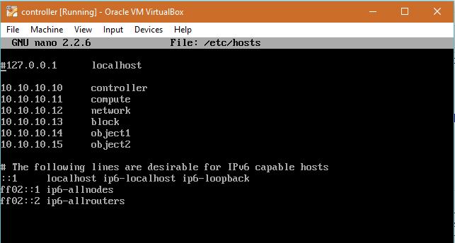

* Create Identity service – keystone

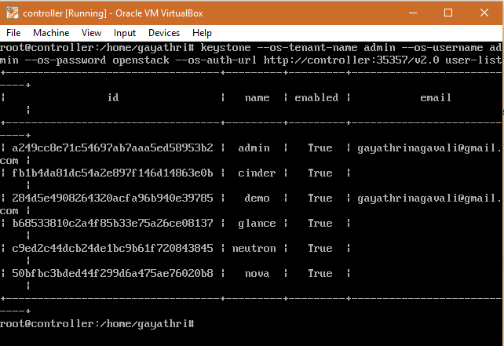

* Create Image service – glance

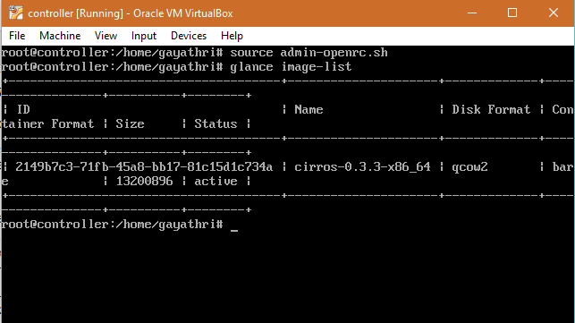

* Configure the Controller and Compute nodes for Nova

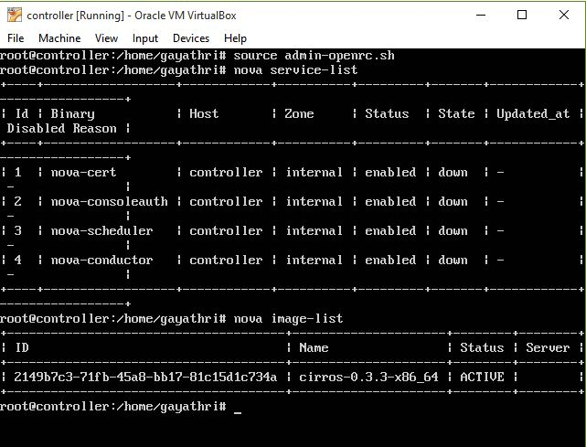

* Configure the Controller and Network nodes for Neutron

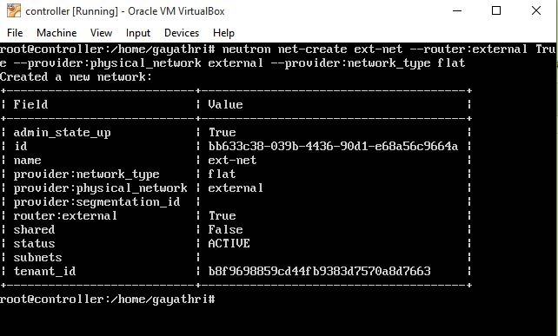

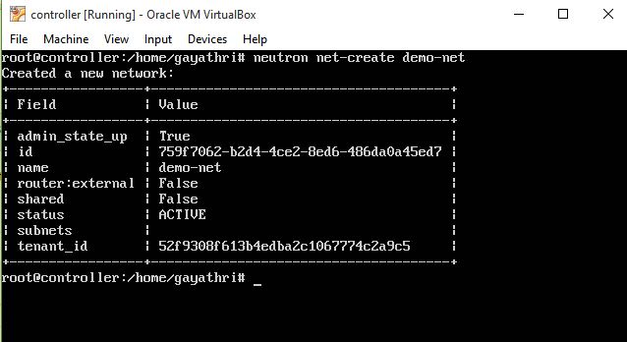

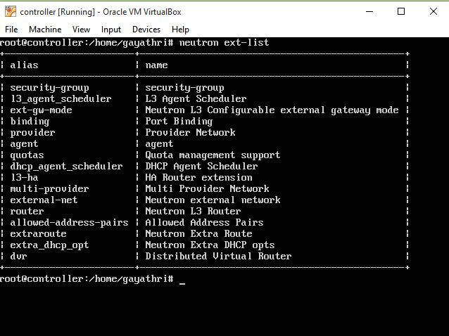

* Configure the nodes for a Dashboard – Horizon

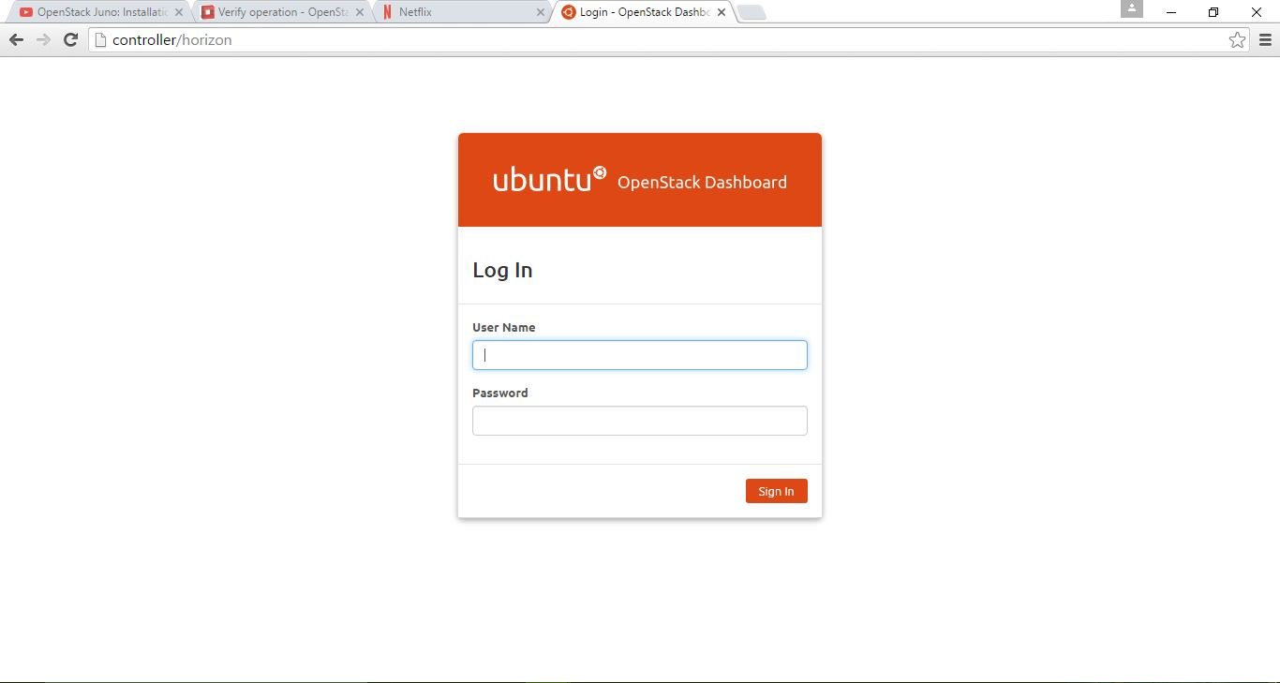

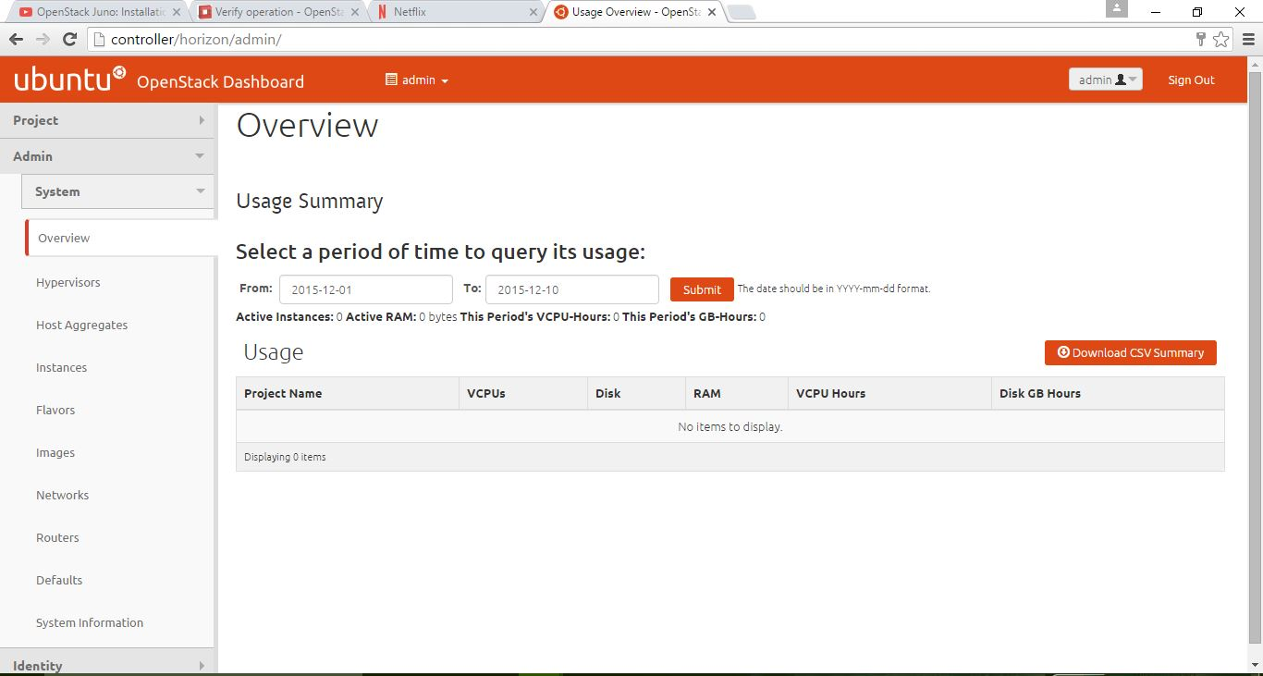

* Rabbitmq server can be accessed as:

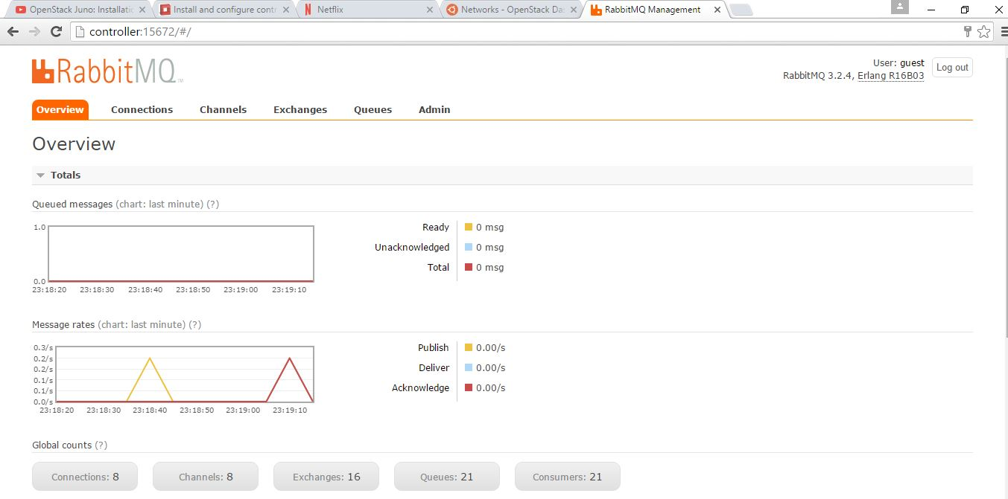

* Now create a new node for Block storage – Cinder
* Configure the controller and block nodes for Cinder and restart the components.
* Cinder service-list command should display the cinder-scheduler and cinder-volume available. But I got an error that displays:

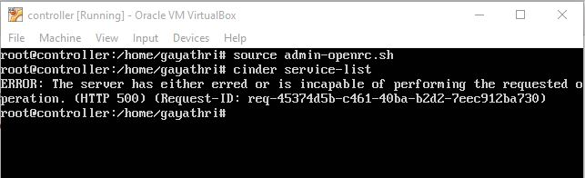

* Create Orchestration – heat by following the steps provided in the documentation.
* Heat stack-list gives the following output:

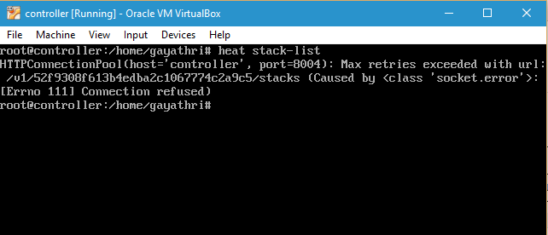

**Installing Openstack using Devstack:**

1. Create Ubuntu Desktop version on Virtual Box to the home page as:

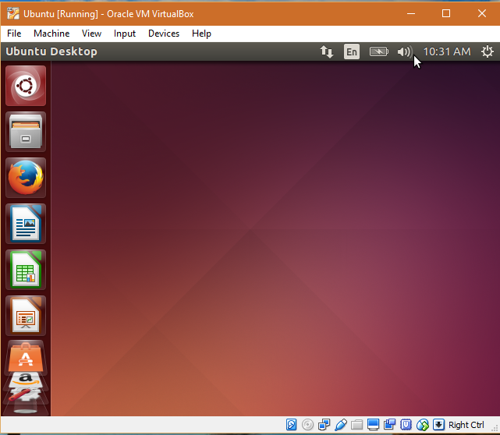

1. Open the terminal and follow the commands:

sudo apt-get update

sudo apt-get install git

git clone https://git.openstack.org/openstack-dev/devstack

cd devstack

sudo apt-get install vim

./stack.sh

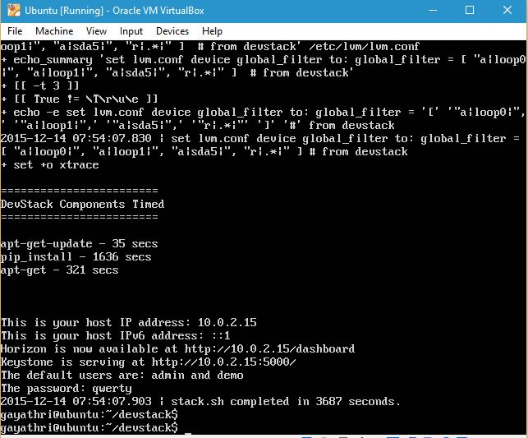

* Open the dashboard and login with the credentials as mentioned above:

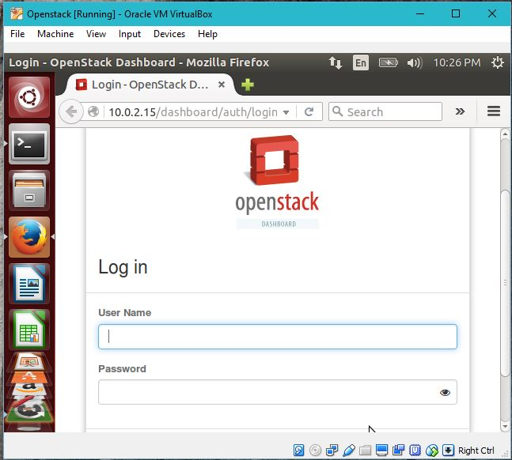

* System information:

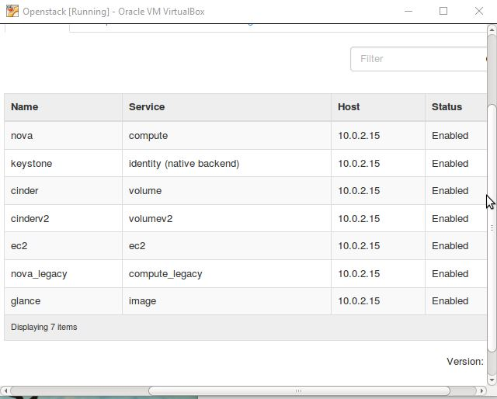

* Generate a private key using Putty gen and upload it while creating an instance:

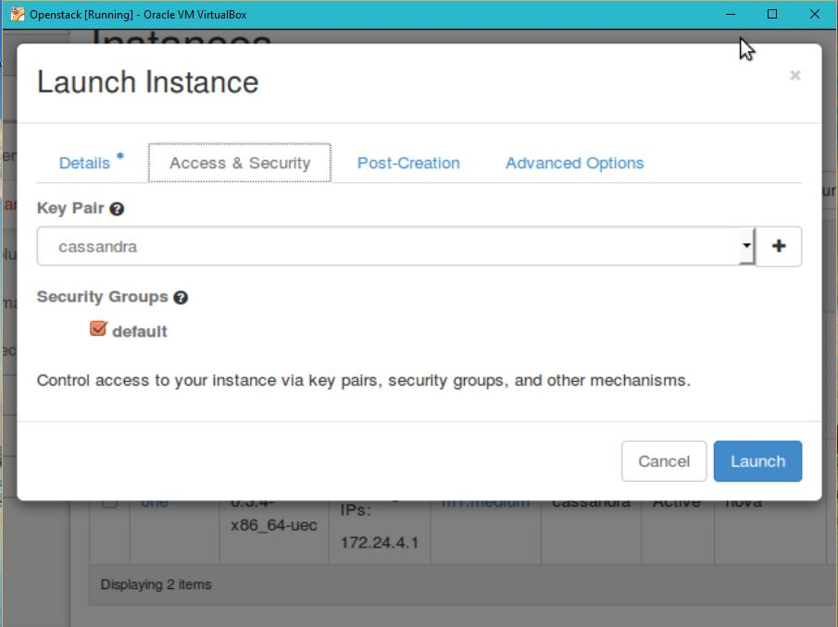

* Launch an instance as following:

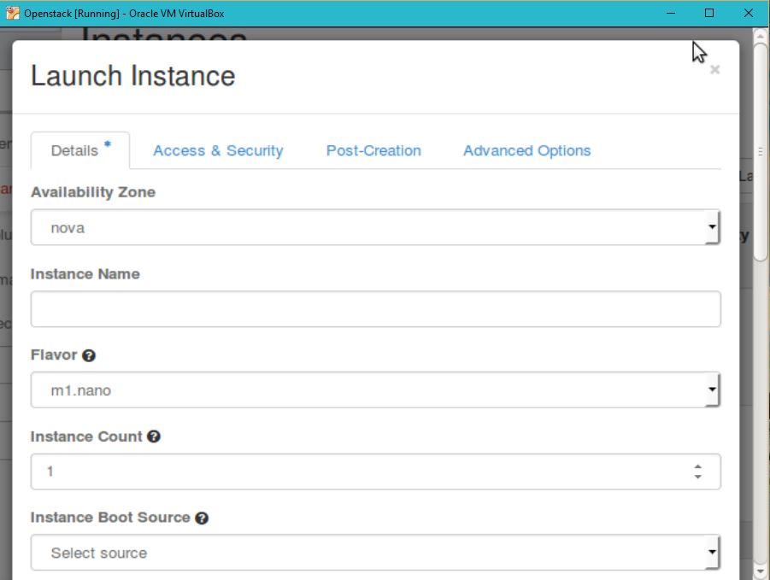

* After launching two instances, you can assign floating IPs to access through putty:

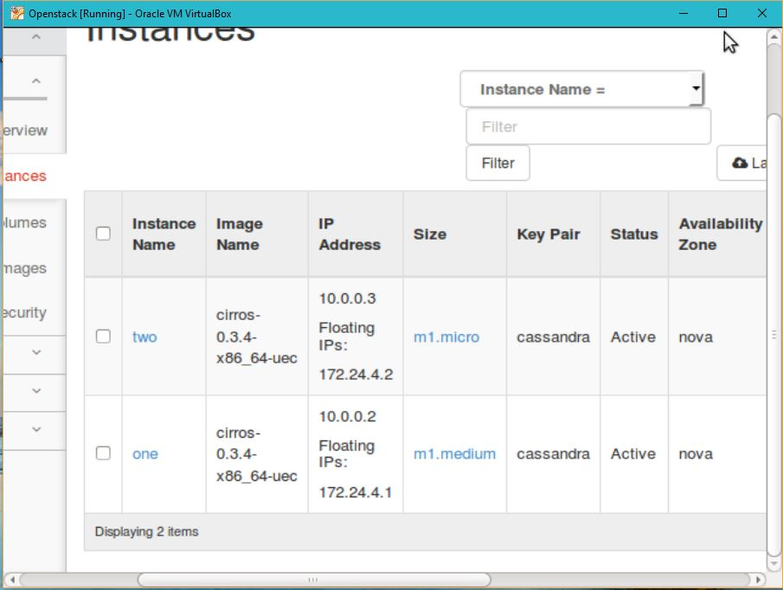

I could not go further because, the connection was very slow and putty became inactive with an error message saying, Network Timed out.

**Errors faced:**

1. While creating keystone and glance, I have faced errors that said, Invalid Openstack credentials.
2. Another error that said, authentication failure.

I have removed all the nodes from virtual box and re-installed.

Then during verification of Block storage installation, I got this error.

I have tried for solutions by checking the log files. Couldn’t make it work.

Few solutions that I have tried:

* Check for maximum connections:

mysql> show status like 'Conn%';

+---------------+-------+

| Variable_name | Value |

+---------------+-------+

| Connections | 69684 |

+---------------+-------+

1 row in set (0.03 sec)

mysql> select @@max_connections;

+-------------------+

| @@max_connections |

+-------------------+

| 151 |

+-------------------+

1 row in set (0.01 sec)

* I have tried to install grizzly as suggested in one of the blogs. But it didn’t help
* Re-checked database to see if cinder was installed. It was installed. I tried to remove it and re-install. The error remained same.



1. I have tried installing devstack. But faced issues with devstack too.

I couldn’t go further as I had an error :

ValueError: need more than 1 value to unpack

Solutions tried:

* Change: LOGFILE=/opt/stack/logs/stack.sh.log  in local.conf
* Tried installing vim and change GIT_BASE git:// to https: in stackrc file.
* Used the following commands:

sudo apt-get upgrade

sudo apt-get dist-upgrade

* I could successfully launch Devstack

1. After creating instances, putty could not launch instances as the connection was too slow.
2. When I refreshed, the instances were deleted automatically.

**Openstack architecture:**

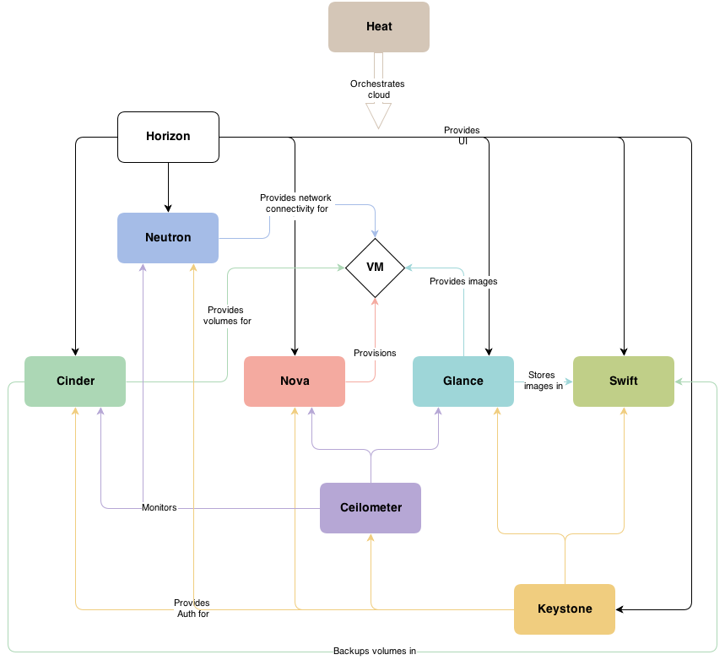

**Basic ontologies:**

**Compute – Nova:** Manages the lifecycle of compute instances in an OpenStack environment. Responsibilities include spawning, scheduling and decommissioning of virtual machines on demand.

**Networking – Neutron**: Enables Network-Connectivity-as-a-Service for other OpenStack services, such as OpenStack Compute. Provides an API for users to define networks and the attachments into them. Has a pluggable architecture that supports many popular networking vendors and technologies.

**Identity service- keystone:** Provides an authentication and authorization service for other OpenStack services. Provides a catalog of endpoints for all OpenStack services.

**Image service- glance:** Stores and retrieves virtual machine disk images. OpenStack Compute makes use of this during instance provisioning.

**Dashboard- Horizon:** Provides a web-based self-service portal to interact with underlying OpenStack services, such as launching an instance, assigning IP addresses and configuring access controls.

**Block Storage – Cinder:** Provides persistent block storage to running instances. Its pluggable driver architecture facilitates the creation and management of block storage devices.

**Object Storage – Swift:** Stores and retrieves arbitrary unstructured data objects via a [RESTful](http://docs.openstack.org/juno/install-guide/install/apt/content/ch_overview.html), HTTP based API. It is highly fault tolerant with its data replication and scale out architecture. Its implementation is not like a file server with mountable directories.

**Telemetry – ceilometer**: Monitors and meters the OpenStack cloud for billing, benchmarking, scalability, and statistical purposes.

**Orchestration – heat**: Orchestrates multiple composite cloud applications by using either the native [HOT](http://docs.openstack.org/juno/install-guide/install/apt/content/ch_overview.html) template format or the AWS CloudFormation template format, through both an OpenStack-native REST API and a CloudFormation-compatible Query API.

**Database service- trove**: Provides scalable and reliable Cloud Database-as-a-Service functionality for both relational and non-relational database engines.